**Add a new country:**

**Country.java:**

package com.example.entity;

import jakarta.persistence.Entity;

import jakarta.persistence.Id;

import jakarta.persistence.Column;

import jakarta.persistence.Table;

*@Entity*

*@Table*(name = "COUNTRY")

public class Country {

*@Id*

*@Column*(name = "CO_CODE")

private String code;

*@Column*(name = "CO_NAME")

private String name;

public String getCode() {

return code;

}

public void setCode(String code) {

this.code = code;

}

public String getName() {

return name;

}

public void setName(String name) {

this.name = name;

}

public Country(String code, String name) {

this.code = code;

this.name = name;

}

public Country() {}

*@Override*

public String toString() {

return "Country{code='" + code + "', name='" + name + "'}";

}}

**CountryService.java:**

package com.example.service;

import com.example.entity.Country;

import com.example.exception.CountryNotFoundException;

import java.util.List;

public interface CountryService {

Country getCountryByCode(String code) throws CountryNotFoundException;

Country addCountry(Country country);

Country updateCountry(Country country);

void deleteCountry(String code);

List<Country> searchCountriesByName(String name);

}

**CountryServiceImpl.java:**

package com.example.service;

import com.example.entity.Country;

import com.example.exception.CountryNotFoundException;

import com.example.repository.CountryRepository;

import org.springframework.beans.factory.annotation.Autowired;

import org.springframework.stereotype.Service;

import org.springframework.transaction.annotation.Transactional;

import java.util.List;

import java.util.Optional;

*@Service*

public class CountryServiceImpl implements CountryService {

*@Autowired*

private CountryRepository repository;

*@Override*

*@Transactional*

public Country getCountryByCode(String code) throws CountryNotFoundException {

Optional<Country> result = repository.findById(code);

if (!result.isPresent()) {

throw new CountryNotFoundException("Country with code '" + code + "' not found.");

}

return result.get();

}

*@Override*

public Country addCountry(Country country) {

return repository.save(country);

}

*@Override*

public Country updateCountry(Country country) {

return repository.save(country);

}

*@Override*

public void deleteCountry(String code) {

repository.deleteById(code);

}

*@Override*

public List<Country> searchCountriesByName(String name) {

return repository.findByNameContainingIgnoreCase(name);

}}

**CountryManagementApplication.java:**

package com.example;

import com.example.entity.Country;

import com.example.exception.CountryNotFoundException;

import com.example.service.CountryService;

import org.slf4j.Logger;

import org.slf4j.LoggerFactory;

import org.springframework.beans.factory.annotation.Autowired;

import org.springframework.boot.CommandLineRunner;

import org.springframework.boot.SpringApplication;

import org.springframework.boot.autoconfigure.SpringBootApplication;

*@SpringBootApplication*

public class CountryManagementApplication implements CommandLineRunner {

private static final Logger LOGGER = LoggerFactory.*getLogger*(CountryManagementApplication.class);

*@Autowired*

private CountryService countryService;

public static void main(String[] args) {

SpringApplication.*run*(CountryManagementApplication.class, args);

}

*@Override*

public void run(String... args) throws Exception {

try {

Country country = countryService.getCountryByCode("IN");

LOGGER.info("Fetched Country: {}", country);

} catch (CountryNotFoundException e) {

LOGGER.error("Error: {}", e.getMessage());

}

Country newCountry = new Country ("JP", "Japan");

countryService.addCountry(newCountry);

try {

Country fetched = countryService.getCountryByCode("JP");

LOGGER.info("Successfully added and fetched country: {}", fetched);

} catch (CountryNotFoundException e) {

LOGGER.error("Error fetching newly added country: {}", e.getMessage());

}

}

}

**data.sql:**

insert into country (co_code, co_name) values ('AF', 'Afghanistan');

insert into country (co_code, co_name) values ('AL', 'Albania');

insert into country (co_code, co_name) values ('DZ', 'Algeria');

insert into country (co_code, co_name) values ('AS', 'American Samoa');

insert into country (co_code, co_name) values ('AD', 'Andorra');

insert into country (co_code, co_name) values ('AO', 'Angola');

insert into country (co_code, co_name) values ('AI', 'Anguilla');

insert into country (co_code, co_name) values ('AQ', 'Antarctica');

insert into country (co_code, co_name) values ('AG', 'Antigua and Barbuda');

insert into country (co_code, co_name) values ('IN', 'India');

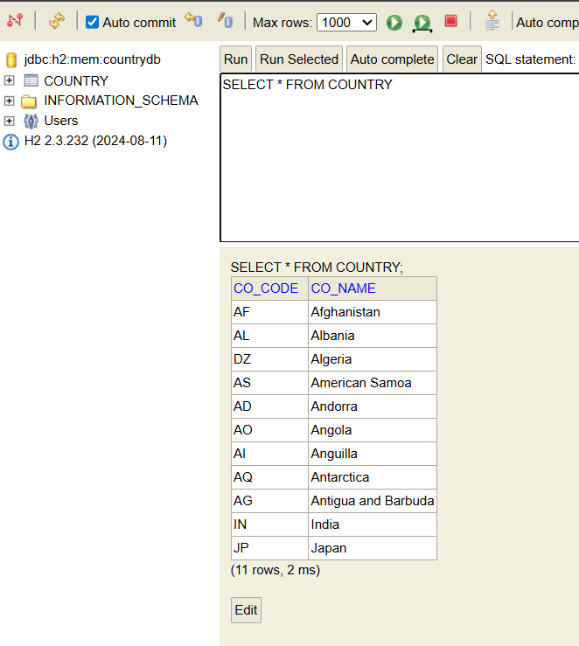

**Here Japan is added to the country**